UUID: VAN0003-LK-33-2 VAN0003-LK-33-2_HBM875.QHDJ.259

Patient #: 65631

Internal #: 71 (FFPE)

A/S/R: 73/F/W

Laterality: Left

(Right, Left)

Anatomical Location: Upper

(U, M, L, N/A)

Dimensions: 24 x 20 x 7

(in mm)

Distance from Tumor: 7

(in cm)

Image:

UUID: VAN0005-RK-1-1 VAN0005-RK-1-1_HBM463.JRTB.582

Patient #: 67347

Internal #: 103

A/S/R: 58/F/W

Laterality: Right

(Right, Left)

Anatomical Location: Lower

(U, M, L, N/A)

Dimensions: 25 x 15 x 6

(in mm)

Distance from Tumor: N/A

(in cm)

Image:

UUID: VAN0005-RK-4-172 VAN0005-RK-4-172_HBM958.GHFM.676

Patient #: 67347

Internal #: 106

A/S/R: 58/F/W

Laterality: Right

(Right, Left)

Anatomical Location: Lower

(U, M, L, N/A)

Dimensions: 28 x 17 x 2

(in mm)

Distance from Tumor: N/A

(in cm)

Image:

UUID: VAN0005-RK-8-2 VAN0005-RK-8-2_HBM636.ZPTS.368

Patient #: 67347

Internal #: 106 (FFPE)

A/S/R: 58/F/W

Laterality: Right

(Right, Left)

Anatomical Location: Lower

(U, M, L, N/A)

Dimensions: 28 x 17 x 2

(in mm)

Distance from Tumor: N/A

(in cm)

Image:

UUID: VAN0006-LK-2-85 VAN0006-LK-2-85_HBM725.PDDC.788

Patient #: 67548

Internal #: 108

A/S/R: 58/M/B

Laterality: Left

(Right, Left)

Anatomical Location: Upper

(U, M, L, N/A)

Dimensions: 18 x 10 x 2

(in mm)

Distance from Tumor: N/A

(in cm)

Image:

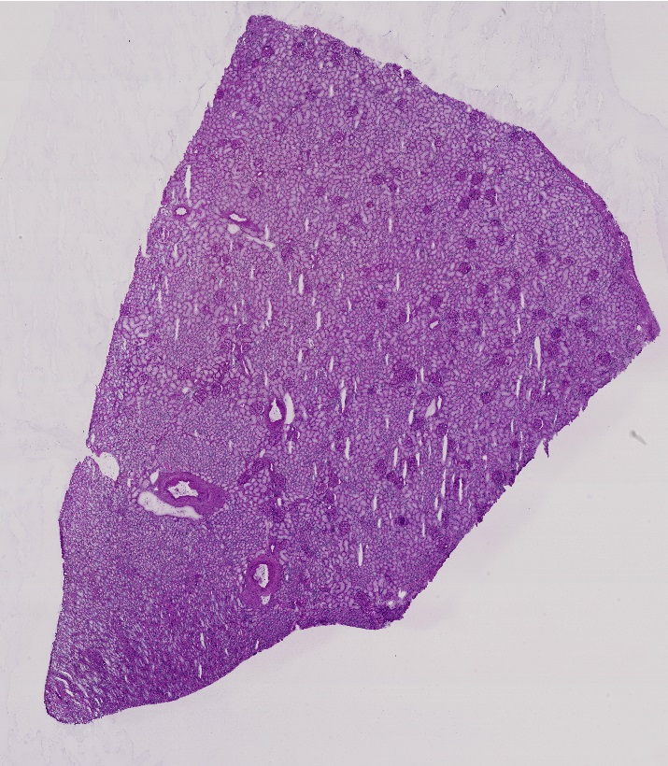

UUID: VAN0006-LK-7-2 VAN0006-LK-7-2_HBM636.GVWP.354

Patient #: 67548

Internal #: 108 (FFPE)

A/S/R: 58/M/B

Laterality: Left

(Right, Left)

Anatomical Location: Upper

(U, M, L, N/A)

Dimensions: 18 x 10 x 2

(in mm)

Distance from Tumor: N/A

(in cm)

Image:

UUID: VAN0007-LK-203-103 VAN0007-LK-203-103_HBM362.PTQJ.743

Patient #: 68138

Internal #: 118

A/S/R: 66/F/W

Laterality: Left

(Right, Left)

Anatomical Location: Lower

(U, M, L, N/A)

Dimensions: 20 x 15 x 4

(in mm)

Distance from Tumor: N/A

(in cm)

Image:

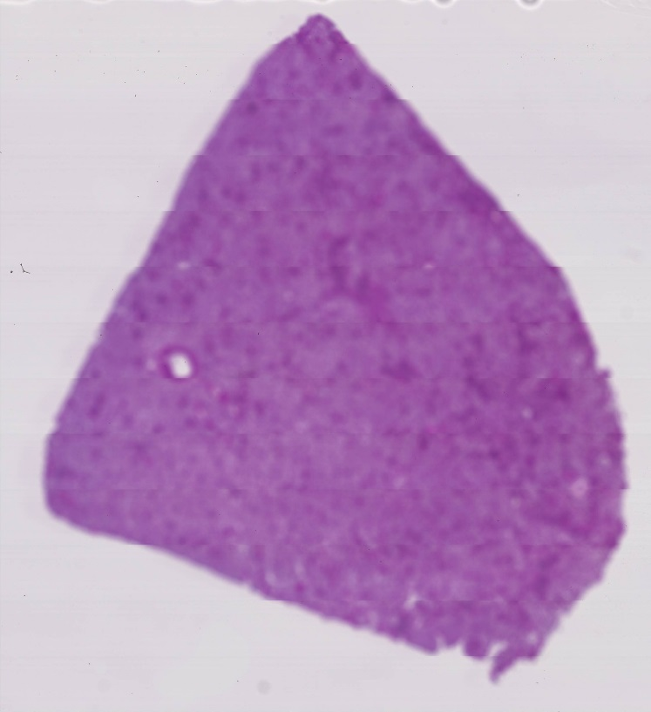

UUID: VAN0008-RK-403-100 VAN0008-RK-403-100_HBM783.GDKK.879

Patient #: 63921

Internal #: 43

A/S/R: 48/M/W

Laterality: Right

(Right, Left)

Anatomical Location: Lower

(U, M, L, N/A)

Dimensions: 15 x 10 x 10

(in mm)

Distance from Tumor: 4

(in cm)

Image:

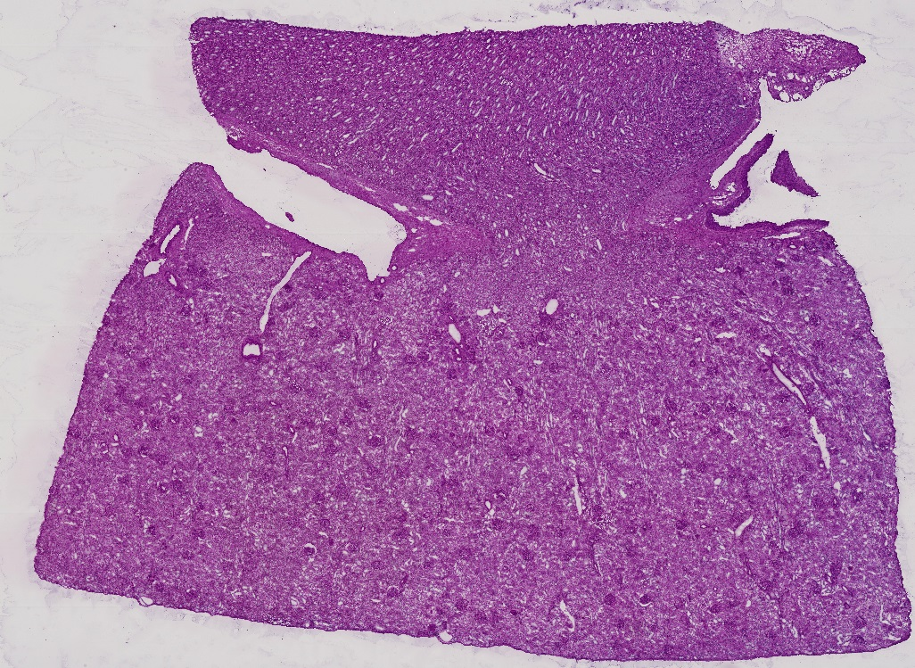

UUID: VAN0009-LK-102-7 VAN0009-LK-102-7_HBM389.MBWW.346

Patient #: 67026

Internal #: 85

A/S/R: 53/M/B

Laterality: Left

(Right, Left)

Anatomical Location: Lower

(U, M, L, N/A)

Dimensions: 20 x 8 x 4

(in mm)

Distance from Tumor: 3.5

(in cm)

Image:

UUID: VAN0009-LK-106-2 VAN0009-LK-106-2_HBM879.CDHB.995

Patient #: 67026

Internal #: 85 (FFPE)

A/S/R: 53/M/B

Laterality: Left

(Right, Left)

Anatomical Location: Lower

(U, M, L, N/A)

Dimensions: 20 x 8 x 4

(in mm)

Distance from Tumor: 3.5

(in cm)

Image:

UUID: VAN0010-LK-155-40 VAN0010-LK-155-40_HBM662.PMPZ.644

Patient #: 67112

Internal #: 92

A/S/R: 56/M/W

Laterality: Left

(Right, Left)

Anatomical Location: Lower

(U, M, L, N/A)

Dimensions: 35 x 19 x 3

(in mm)

Distance from Tumor: 5

(in cm)

Image:

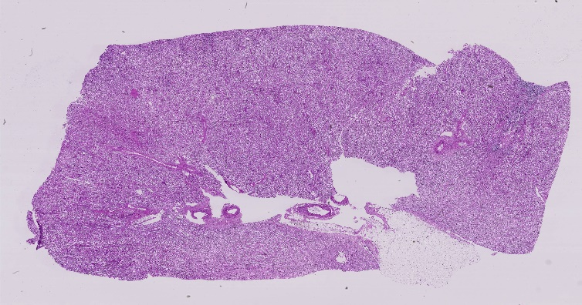

UUID: VAN0012-RK-103-75 VAN0012-RK-103-75_HBM874.RZDW.757

Patient #: 68250

Internal #: 122

A/S/R: 44/F/W

Laterality: Right

(Right, Left)

Anatomical Location: Lower

(U, M, L, N/A)

Dimensions: 17 x 18 x 3

(in mm)

Distance from Tumor: N/A

(in cm)

Image:

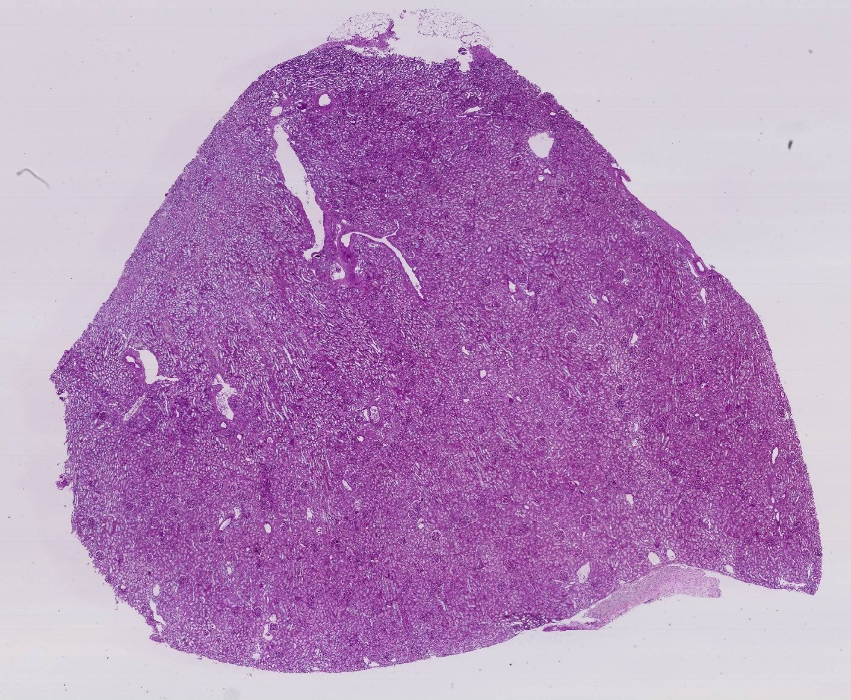

UUID: VAN0013-LK-202-96 VAN0013-LK-202-96_HBM849.XMPC.398

Patient #: 68304

Internal #: 125

A/S/R: 61/F/W

Laterality: Left

(Right, Left)

Anatomical Location: Lower

(U, M, L, N/A)

Dimensions: 19 x 15 x 3

(in mm)

Distance from Tumor: N/A

(in cm)

Image:

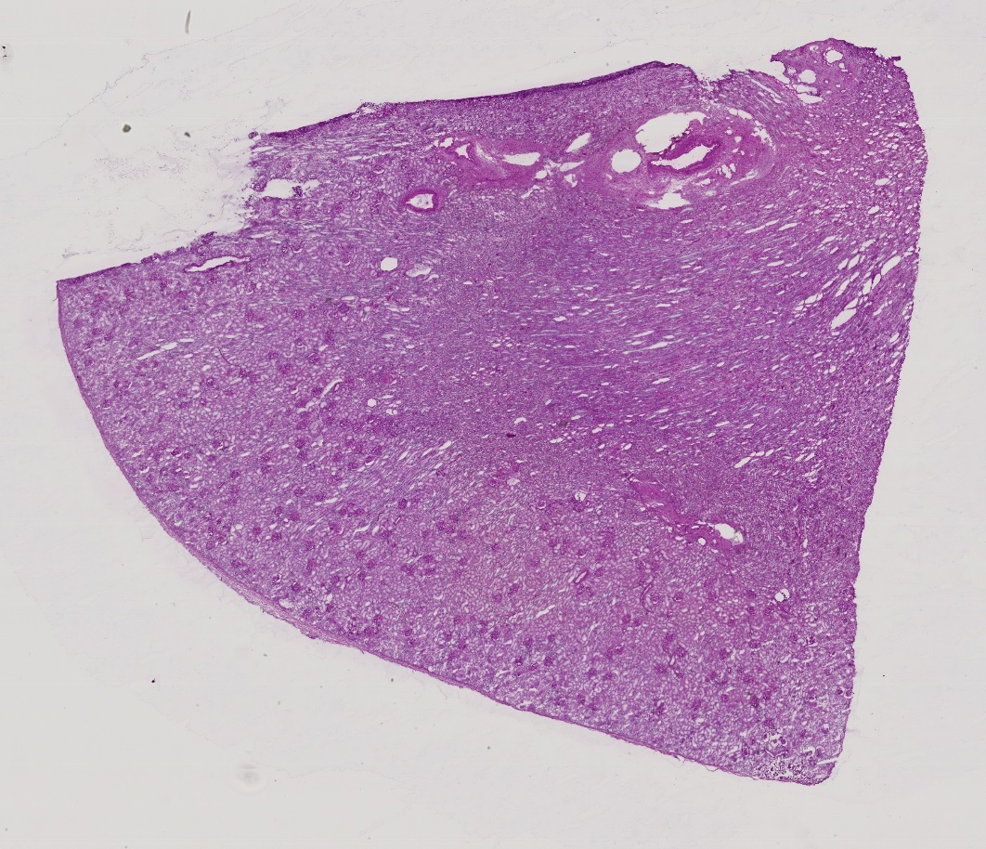

UUID: VAN0014-LK-203-108 VAN0014-LK-203-108_HBM979.HDZH.896

Patient #: 68555

Internal #: 130

A/S/R: 76/F/W

Laterality: Left

(Right, Left)

Anatomical Location: Lower

(U, M, L, N/A)

Dimensions: 20 x 14 x 5

(in mm)

Distance from Tumor: N/A

(in cm)

Image:

UUID: VAN0016-LK-202-89 VAN0016-LK-202-89_HBM264.XSVF.528

Patient #: 66999

Internal #: 133

A/S/R: 56/M/W

Laterality: Left

(Right, Left)

Anatomical Location: Upper

(U, M, L, N/A)

Dimensions: 33 x 23 x 4

(in mm)

Distance from Tumor: 3

(in cm)

Image:

